Acceptance tests   
Acme-Packages 1.0

|  |  |
| --- | --- |
| ****Development team**** | |
| **Identifier** | G26 |
| **Members** | Valero García, Luis; de los Reyes García, José Manuel; Mora Carrero, Adrián; Mohamed Pérez, Abdelha; Muñoz Espejo, Domingo |
| **Testing team** | |
| **Identifier** | G98 |
| **Members** | Salguero Álvarez, Tania; López Heredia, Gonzalo; Serrano Fernández, Damián; Lozano Tore, Carlos; Cuevas Carrasco, David |
| **Indexing data** | |
| **Test designers** | Valero García, Luis; de los Reyes García, José Manuel; Mora Carrero, Adrián; Mohamed Pérez, Abdelha; Muñoz Espejo, Domingo |
| **Testers** | Salguero Álvarez, Tania; López Heredia, Gonzalo; Serrano Fernández, Damián; Lozano Tore, Carlos; Cuevas Carrasco, David |
| **Notes** |  |

Table of contents

Use case UC01 List of curricula 4

Use case UC02 Display of curriculum 4

Use case UC03 Management of curriculum 5

Use case UC04 List of categories 7

Use case UC05 Management of categories 8

Use case UC06 List of Message boxes 10

Use case UC07 List the messages of a Message box 11

Use case UC08 Management of Message boxes 11

Use case UC09 Display a message 13

Use case UC10 Management of Messages 14

Use case UC11 Display of Miscellaneous Records 18

Use case UC12 Manage Miscellaneous Records 18

Use case UC13 List of Offers 21

Use case UC14 Display of Offers 22

Use case UC15 Manage of Offers 24

Use case UC16 List of Packages 27

Use case UC17 Manage of Packages 28

Use case UC18 List of Evaluations 30

Use case UC19 Manage Evaluations 31

Use case UC20 List social profile. 32

Use case UC21 Create a social profile. 33

Use case UC22 Edit a social Profile. 36

Use case UC23 Delete a social profile. 38

Use case UC24 List sponsorships. 39

Use case UC25 Create a sponsorship. 40

Use case UC26 Edit a sponsorship. 41

Use case UC27 Delete a sponsorship. 42

Use case UC28 List fares. 43

Use case UC29 Create a fare. 44

Use case UC30 Edit a fare. 46

Use case UC31 Delete a fare. 47

Use case UC32 List traverse towns. 48

Use case UC33 Create a traverse town. 49

Use case UC34 Edit a traverse town. 51

Use case UC35 Delete a traverse town. 53

Use case UC36 List requests. 54

Use case UC37 Create a request. 56

Use case UC38 Edit a request. 59

Use case UC39 Delete a request. 61

Use case UC40 Manage towns 62

Use case UC41 Management of issues 64

Use case UC42 manage professional records 68

Use case UC43 Display dashboard. 69

Use case UC44 Calculate spammers, compute carrier score, send notification to sponsor about their sponsorships and invalid undated sponsorships. 71

Use case UC45 Ban actors 72

Use case UC46 Finder 73

Use case UC47 Register as user 77

Use case UC48 Create a user being an administrator 81

Use case UC49 Display personal data 84

Use case UC50 Manage personal data 85

Use case UC51 List of vehicles 88

Use case UC52 Display of vehicles 89

Use case UC53 Manage of vehicles 90

Use case UC54 List of solicitations 93

Use case UC55 Manage of solicitations 94

# Use case UC01 List of curricula

Description

Every carrier can list its curricula.

Access

By clicking in “Curricula” on the navigation bar.

Tests

|  |  |
| --- | --- |
| **Test 001** | |
| **Description** | A logged carrier wants to see its curricula. |
| **Expected** | A list page with the curriculums of the carrier1 (carrier1). |
| **Outcome** |  |
| **Notes** |  |

# Use case UC02 Display of curriculum

Description

Carriers can display its curriculums.

Access

By clicking in “Curricula” on the navigation bar and selecting one of the created curriculums clicking in the “Full name” field.

Tests

|  |  |
| --- | --- |
| **Test 001** | |
| **Description** | A logged carrier wants to see one of its curriculums. |
| **Expected** | A display of the selected curriculum (id=XXXX). |
| **Outcome** |  |
| **Notes** |  |

# Use case UC03 Management of curriculum

Description

Carrier can manage its curriculums.

Access

By clicking in “Curricula” on the navigation bar.

Tests

|  |  |
| --- | --- |
| **Test 001** | |
| **Description** | A logged rookie wants to create a new curriculum, so it clicks the “Create” link at the bottom. Once inside he enters the personal data. |
| **Expected** | If the data is correct the system will redirect to the display of the new curriculum. |
| **Outcome** |  |
| **Notes** |  |

|  |  |
| --- | --- |
| **Test 002** | |
| **Description** | A logged carrier wants to create a new curriculum, so it clicks the “Create” link at the bottom. Once inside he enters incorrect data. |
| **Expected** |  |
| **Outcome** |  |
| **Notes** |  |

|  |  |
| --- | --- |
| **Test 003** | |
| **Description** | A logged carrier wants to edit one of his curriculums, so it clicks the link in the column “Full name” to enter in its display view. Once inside the rookie clicks the edit link of the personal data. |
| **Expected** | If the data is correct, the system will redirect to the display view. |
| **Outcome** |  |
| **Notes** |  |

|  |  |
| --- | --- |
| **Test 004** | |
| **Description** | A logged carrier wants to delete one of his curriculums, so in the edit view he clicks the delete button. |
| **Expected** | If everything is OK, the system will redirect to the list page. A confirmation is required. |
| **Outcome** |  |
| **Notes** |  |

# Use case UC04 List of categories

Description

Every administrator can list the catalogue of categories.

Access

By clicking in “Categories” in the navigation bar.

Tests

|  |  |
| --- | --- |
| **Test 001** | |
| **Description** | A logged admin wants to see the catalogue of categories. |
| **Expected** | A list page with the categories of the system (admin). |
| **Outcome** |  |
| **Notes** | Name and description of categories are shown depending on what language is currently using. |

# Use case UC05 Management of categories

Description

Administrator can manage the catalogue of categories.

Access

By clicking in “Categories” in the navigation bar.

Tests

|  |  |
| --- | --- |
| **Test 001** | |
| **Description** | A logged administrator wants to create a new category, so it clicks the “Create category” link at the bottom. Once inside he enters the data. |
| **Expected** | If the data is correct the system will redirect to the list of the categories of the system. |
| **Outcome** |  |
| **Notes** |  |

|  |  |
| --- | --- |
| **Test 002** | |
| **Description** | A logged administrator wants to create a new category, so it clicks the “Create” link at the bottom. Once inside he enters incorrect data. |
| **Expected** |  |
| **Outcome** |  |
| **Notes** |  |

|  |  |
| --- | --- |
| **Test 003** | |
| **Description** | A logged carrier wants to edit a category, so it clicks on “Edit Category” of category (“Name in English = Heavy”) |
| **Expected** | If the data is correct, the system will redirect to the catalogue of categories. |
| **Outcome** |  |
| **Notes** | Only fields editable about a category are English description and Spanish description. |

|  |  |
| --- | --- |
| **Test 004** | |
| **Description** | A logged carrier wants to delete a category, the previously one, so in the edit view he clicks the delete button. |
| **Expected** | If everything is OK, the system will redirect to the list page. A confirmation is required. |
| **Outcome** |  |
| **Notes** |  |

|  |  |
| --- | --- |
| **Test 005** | |
| **Description** | A logged carrier wants to delete a category, but the category is currently used by a package or an offer. |
| **Expected** | The system must display an error like the following picture. |
| **Outcome** |  |
| **Notes** |  |

# Use case UC06 List of Message boxes

Description

Every actor can list its Message boxes.

Access

By clicking in “Messages” on the navigation bar.

Tests

|  |  |
| --- | --- |
| **Test 001** | |
| **Description** | A logged actor wants to see its message boxes. |
| **Expected** | A list page with the message boxes of the actor (admin). |
| **Outcome** |  |
| **Notes** |  |

# Use case UC07 List the messages of a Message box

Description

Actors can list the messages of a message box.

Access

By clicking in “Messages” on the navigation bar and selecting one of the current message boxes clicking in the “List of messages in the box” field.

Tests

|  |  |
| --- | --- |
| **Test 001** | |
| **Description** | A logged actor wants to list the messages of a message box (outbox). |
| **Expected** | A list of messages stored in the message box. |
| **Outcome** |  |
| **Notes** |  |

# Use case UC08 Management of Message boxes

Description

A logged actor can manage its message boxes, if the message box is not a system box.

Access

By clicking in “Message box” in the navigation bar.

Tests

|  |  |
| --- | --- |
| **Test 001** | |
| **Description** | A logged actor wants to create a new message box, so it clicks the “Create a Message box” link at the bottom. Once inside he enters the data. |
| **Expected** | If the data is correct the system will redirect to the display of the list of message boxes. |
| **Outcome** |  |
| **Notes** |  |

|  |  |
| --- | --- |
| **Test 002** | |
| **Description** | A logged actor wants to create a message box, so it clicks the “Create a Message box” link at the bottom. Once inside he enters incorrect data. |
| **Expected** |  |
| **Outcome** |  |
| **Notes** |  |

|  |  |
| --- | --- |
| **Test 003** | |
| **Description** | A logged carrier wants to edit a message box, so it clicks the link in the column “Edit” to enter in its edit view. |
| **Expected** | If the data is correct, the system will redirect to the list of message boxes of the logged actor. |
| **Outcome** |  |
| **Notes** | A system message box cannot be edited. |

|  |  |
| --- | --- |
| **Test 004** | |
| **Description** | A logged actor wants to delete one of the message boxes, , so in the edit view he clicks the delete button. |
| **Expected** | If everything is OK, the system will redirect to the list page. A confirmation is required. |
| **Outcome** |  |
| **Notes** | A system message box cannot be deleted. |

# Use case UC09 Display a message

Description

Every actor can display his/her messages.

Access

By clicking in “Messages” on the navigation bar. Click on the link in the column “List of messages in the box”. Then click on the link in the column ”View in details of message”

Tests

|  |  |
| --- | --- |
| **Test 001** | |
| **Description** | A logged actor wants to see a message. |
| **Expected** | A view where shows the display of the message with the fields: ‘Subject, sender, send date, body, recipient and tags’. |
| **Outcome** |  |
| **Notes** |  |

# Use case UC10 Management of Messages

Description

A logged actor can manage its messages.

Access

By clicking in “Message box” in the navigation bar.

Tests

|  |  |
| --- | --- |
| **Test 001** | |
| **Description** | A logged actor wants to send a message, so it clicks the “Create a Message” link at the top. Once inside he enters the data. Then push button “Send message”. User:(admin) |
| **Expected** | If the data is correct the system will redirect to the display of the sent message |
| **Outcome** |  |
| **Notes** |  |

|  |  |
| --- | --- |
| **Test 002** | |
| **Description** | A logged actor wants to send a message, so it clicks the “Create a Message” link at the top. Once inside he enters incorrect data. Then push button “Send message” |
| **Expected** |  |
| **Outcome** |  |
| **Notes** |  |
| **Test 003** | |
| **Description** | A logged administrator wants to send a broadcast message, so it clicks the “Create a Message” link at the top. Once inside he enters correct data. Then push button “Send a notification message” |
| **Expected** |  |
| **Outcome** |  |
| **Notes** |  |

|  |  |
| --- | --- |
| **Test 004** | |
| **Description** | A logged administrator wants to send a broadcast message, so it clicks the “Create a Message” link at the top. Once inside he enters incorrect data. Then push button “Send a notification message” |
| **Expected** |  |
| **Outcome** |  |
| **Notes** |  |

|  |  |
| --- | --- |
| **Test 005** | |
| **Description** | A logged actor wants to copy one of the messages, to a not-system message box, so in the display view he clicks the “copy” button. Then, shows a view to select a Message box to copy the message. |
| **Expected** | If everything is OK, the system will redirect to the list page. A confirmation is required.    1 Create a new Message box 2 Display of any message and push Copy    3 Select the message box previously created    4 List messages of the message box selected |
| **Outcome** |  |
| **Notes** | A system message box cannot be selected as destination. |

|  |  |
| --- | --- |
| **Test 006** | |
| **Description** | A logged actor wants to move one of the messages to a not-system message box, so in the display view he clicks the “move” button. Then, shows a view to select from which box will move a Message to another Message box. |
| **Expected** | 1 Create a new Message box 2 Display of any message and push Move    3 Select the message box source and a message box destination    4 List messages of the message box selected as destination |
| **Outcome** |  |
| **Notes** | A system message box cannot be selected as destination. |

|  |  |
| --- | --- |
| **Test 007** | |
| **Description** | A logged actor wants to delete one of the messages from a message box, so in the display view he clicks the “delete” button. Then, shows a view to select from which box will delete it. If the message is already in the trash box, and the source to delete the message is “Trash box”, the message will be removed from every message box and the system. |
| **Expected** | 1.Display of any message, push Delete 2. Select the message box source    3. List messages of the trash box |
| **Outcome** |  |
| **Notes** |  |

# Use case UC11 Display of Miscellaneous Records

Description

Every actor of the system can see the miscellaneous records of the curriculums of the carriers of the system.

Access

Offers > Link to the carrier of the first offer > Curricula > Link of one of the curriculums

Tests

|  |  |
| --- | --- |
| **Test 001** | |
| **Description** | A logged or non-logged actor wants to see the miscellaneous record of one curriculum. |
| **Expected** | Inside the display of the curriculum the user should see its miscellaneous records, if any. |
| **Outcome** |  |
| **Notes** |  |

# Use case UC12 Manage Miscellaneous Records

Description

Carriers can manage the miscellaneous records of his curriculums.

Access

Logged as a carrier > Curricula

Tests

|  |  |
| --- | --- |
| **Test 001** | |
| **Description** | A carrier wants to add a miscellaneous record to one of his curriculums. |
| **Expected** | Inside a created curriculum, in the miscellaneous record section it should be an “Add” link.    Once clicked it should show this form.    These are the expected errors:    Once the information is correct and the user clicks the save button, the page should redirect to the display page where the new miscellaneous record can be seen. |
| **Outcome** |  |
| **Notes** |  |

|  |  |
| --- | --- |
| **Test 002** | |
| **Description** | A carrier wants to edit one of his miscellaneous records. |
| **Expected** | Inside a created curriculum with a miscellaneous record, the user should see this:    The user can edit the record by clicking the “Edit” link. Once inside the edition form these are the expected errors with invalid information.    If the information is correct, the record will be updated, and the user will be redirected to the display page of the curriculum. |
| **Outcome** |  |
| **Notes** |  |

|  |  |
| --- | --- |
| **Test 003** | |
| **Description** | A carrier wants to delete one of his miscellaneous records. |
| **Expected** | Inside a created curriculum with a miscellaneous record, the user should see this:    The user can edit the record by clicking the “Edit” link. Once inside the edition form, the user should see a “Delete” button.    If the user clicks the button the system will ask for confirmation.    Once deleted the system will redirect to the display page, where the delete miscellaneous record shouldn’t be found. |
| **Outcome** |  |
| **Notes** |  |

# Use case UC13 List of Offers

Description

Any user of the system can see the available offers.

Access

Offers

Tests

|  |  |
| --- | --- |
| **Test 001** | |
| **Description** | A user wants to see the available offers of the system. |
| **Expected** | The offers can be ordered by the maximum date to request.  All the links should work. |
| **Outcome** |  |
| **Notes** |  |

|  |  |
| --- | --- |
| **Test 002** | |
| **Description** | A carrier wants to see its offers. |
| **Expected** | As carrier1 go to “My Offers”    The user should see its offers and a “Create” link.  All the links should work. |
| **Outcome** |  |
| **Notes** |  |

|  |  |
| --- | --- |
| **Test 003** | |
| **Description** | Users can filter the list of packages by the name of a town. |
| **Expected** | As any user go to “Offers”.  Above the list there must be a text box, where you can filter by town.  If we search for “huesca” whe should get the following offer:    If we see the offer, we’ll see that one of its towns is Huesca. |
| **Outcome** |  |
| **Notes** |  |

# Use case UC14 Display of Offers

Description

Any user of the system can see the available offers.

Access

Offers

Tests

|  |  |
| --- | --- |
| **Test 001** | |
| **Description** | As any type of user except carrier, the system should show this when clicking the ticker of one of the offers in “Offers”. |
| **Expected** | Clicking the first one:    All the links should work. |
| **Outcome** |  |
| **Notes** |  |

|  |  |
| --- | --- |
| **Test 002** | |
| **Description** | As the carrier1, the system should show this when clicking the first ticker in the list of offers in “My offers”. |
| **Expected** | In this case the user can see the edit button because the offer is not cancelled.  If we see the third offer, we won’t see that button.    All the links should work. |
| **Outcome** |  |
| **Notes** |  |

|  |  |
| --- | --- |
| **Test 003** | |
| **Description** | As the carrier1, the system should show this when clicking the first ticker in the list of offers in “My offers”. |
| **Expected** | In this case the user can see the edit button because the offer is not cancelled.  If we see the third offer, we won’t see that button.    All the links should work. |
| **Outcome** |  |
| **Notes** |  |

# Use case UC15 Manage of Offers

Description

Carriers of the system can manage his offers.

Access

As a carrier > My Offers

Tests

|  |  |
| --- | --- |
| **Test 001** | |
| **Description** | A carrier can create an offer. |
| **Expected** | Inside “My Offers” click the “Create” button.    These are the expected errors:    Once created the system will redirect to the display of the offer: |
| **Outcome** |  |
| **Notes** |  |

|  |  |
| --- | --- |
| **Test 002** | |
| **Description** | A carrier can edit an offer. |
| **Expected** | With the offer created in the previous test and inside its display, click the “Edit” button. The system will show this:    There are new expected errors:    Once added a traverse town we can set the offer in final mode.  Now that is in final mode the only thing we can do is to cancel it:    Once in final mode the “Edit” link will no longer appear. |
| **Outcome** |  |
| **Notes** |  |

|  |  |
| --- | --- |
| **Test 003** | |
| **Description** | A carrier can delete an offer. |
| **Expected** | If the offer is not in final mode, it can be deleted by its carrier.    The system will ask for confirmation. |
| **Outcome** |  |
| **Notes** |  |

# Use case UC16 List of Packages

Description

Carriers and customers can list packages.

Access

As a carrier > My Offers

Tests

|  |  |
| --- | --- |
| **Test 001** | |
| **Description** | A carrier can list the packages of the requests of any of his offers. |
| **Expected** | As carrier1 go to “My offers”, click “Requests” link of the first offer and once inside the list of the request of that offer click the first offer. The carrier should see this list of packages at the bottom of the page: |
| **Outcome** |  |
| **Notes** |  |

|  |  |
| --- | --- |
| **Test 002** | |
| **Description** | A customer can list the package of his requests. |
| **Expected** | As customer1 go to “Requests” and click the ticker of the first request. The packages can be seen at the bottom of the page. |
| **Outcome** |  |
| **Notes** |  |

|  |  |
| --- | --- |
| **Test 003** | |
| **Description** | A customer can list the package of his requests. |
| **Expected** | As customer1 go to “Requests” and click the ticker of the first request. The packages can be seen at the bottom of the page. |
| **Outcome** |  |
| **Notes** |  |

# Use case UC17 Manage of Packages

Description

Customers can manage their packages.

Access

As a customer > Requests

Tests

|  |  |
| --- | --- |
| **Test 001** | |
| **Description** | A customer can add packages to his requests while they aren’t in final mode. |
| **Expected** | As customer4 go to “Requests” and click the ticker of the first one.  Now you will see a button at the bottom to add packages.    Click the button and the system will redirect you to a form to add a new package t this offer. These are the expected errors:    Once saved properly the system will redirect to the previous page where we can see the new package. |
| **Outcome** |  |
| **Notes** |  |

|  |  |
| --- | --- |
| **Test 002** | |
| **Description** | A customer can edit a package of a requests that’s not in final mode. |
| **Expected** | As customer4 go to “Requests” and click the ticker of the first one.  Now you will see a button at the bottom to add packages.    Click the “Edit” link of the package and you will see this:    The package cannot be deleted but can be modified.  Once modified properly the system will redirect to the previous display page. |
| **Outcome** |  |
| **Notes** |  |

|  |  |
| --- | --- |
| **Test 003** | |
| **Description** | A customer can delete a package of a requests that’s not in final mode. |
| **Expected** | As customer4 go to “Requests” and click the ticker of the first one.  Now you will see a button at the bottom to add packages.    In order to edit a package, we need to add a new one.  Once added, go to the edit form of the new package and click the delete button. It should ask for confirmation. If the operation is success, the system will redirect to the display of the request. |
| **Outcome** |  |
| **Notes** |  |

# Use case UC18 List of Evaluations

Description

Carriers and customers can list his evaluations.

The evaluations of any offer can be listed by authenticated users.

Access

As an authenticated user Offers > Click the first offer

Tests

|  |  |
| --- | --- |
| **Test 001** | |
| **Description** | An authenticated user can list the evaluations of a certain offer. |
| **Expected** | Inside the display of the first offer in “Offers”, click the “Evaluations” button.    All the links should work. |
| **Outcome** |  |
| **Notes** |  |

|  |  |
| --- | --- |
| **Test 002** | |
| **Description** | An authenticated carrier can see his received evaluations. |
| **Expected** | By clicking the “Evaluations” button in the navigation bar, the carrier should see:    All the links should work. |
| **Outcome** |  |
| **Notes** |  |

|  |  |
| --- | --- |
| **Test 003** | |
| **Description** | An authenticated customer can see the evaluations he or she has done. |
| **Expected** | By clicking the “Evaluations” button in the navigation bar, the customer should see:    All the links should work. |
| **Outcome** |  |
| **Notes** |  |

# Use case UC19 Manage Evaluations

Description

Customers can manage evaluations.

Access

As an authenticated customer > Evaluations

Tests

|  |  |  |
| --- | --- | --- |
| **Test 001** | | |
| **Description** | Inside “Evaluations”, the customer can delete the evaluations he or she has made. | |
| **Expected** | A “Delete button should” appear for each evaluation in the list.  The system should ask for confirmation.    The system will redirect to the same list. | |
| **Outcome** |  | |
| **Notes** |  | |
| **Test 002** | | |
| **Description** | | Customers can create evaluations. For this, the customer needs to access the display of the corresponding offer. As customer2 go to the display of the first offer shown in “Offers”. |
| **Expected** | | If the customer has an accepted request for the offer he or she is displaying, then a “New evaluation” link will appear.    Once clicked the system will show a creation form.  These are the expected errors:    Once saved, the system will redirect to the display of the offer.  The new evaluation can be seen inside the list of evaluations in the display of the offer.  The score of the offer must’ve been recomputed, but only the carrier owner can see it.  The carrier of the offer must have a message saying that he has a new evaluation. |
| **Outcome** | |  |
| **Notes** | |  |

# Use case UC20 List social profile.

Description

An authenticated actor can list his social profiles.

Access

Login > Main menu > Profile > Social Profiles

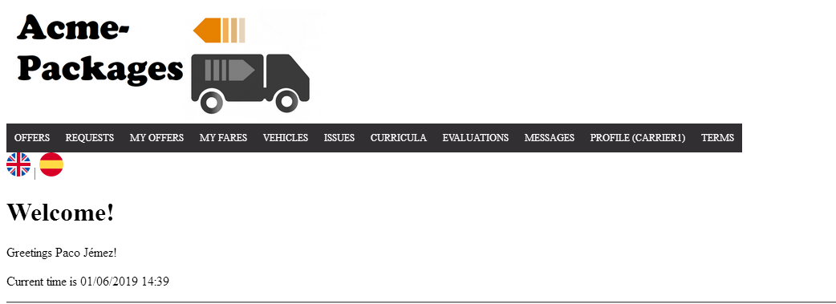

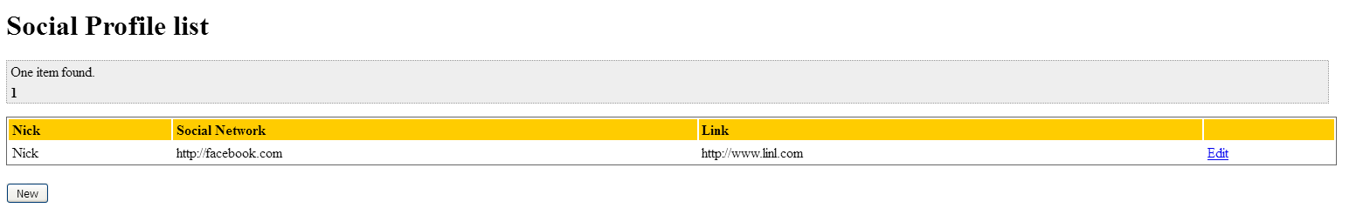

Tests

|  |  |
| --- | --- |
| **Test 001** | |
| **Description** | An actor can list his social Profile. |
| **Expected** | The system must return to a view where shows a list of social profiles owned by the logged actor |
| **Outcome** |  |
| **Notes** |  |

|  |  |
| --- | --- |
| **Test 002** | |
| **Description** | A non-authenticated actor tries to access to the list of social profiles by URL |
| **Expected** | The system must return the user to the index page. |
| **Outcome** |  |
| **Notes** |  |

# Use case UC21 Create a social profile.

Description

An authenticated actor can create a social profile.

Access

Login > Main menu > Profile > Social profiles > New



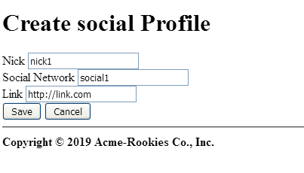

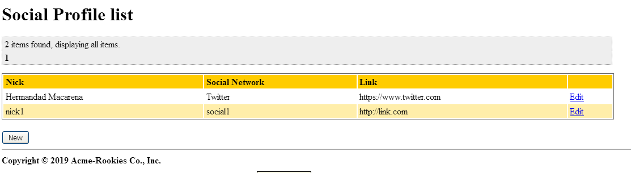Tests

|  |  |
| --- | --- |
| **Test 001** | |
| **Description** | An actor can create a social profile. We fill the form with valid data |
| **Expected** | The system must return to a view where shows a list of social profiles owned by the logged actor, including the new social profile created. |
| **Outcome** |  |
| **Notes** |  |

|  |  |
| --- | --- |
| **Test 002** | |
| **Description** | Click on “Save” button without filling the form |
| **Expected** |  |
| **Outcome** |  |
| **Notes** |  |

|  |  |
| --- | --- |
| **Test 003** | |
| **Description** | An actor tries to fill the form with non-valid data |
| **Expected** |  |
| **Outcome** |  |
| **Notes** |  |

|  |  |
| --- | --- |
| **Test 004** | |
| **Description** | Click on “cancel” button. |
| **Expected** | The system must return to the list of social profiles |
| **Outcome** |  |
| **Notes** |  |

|  |  |
| --- | --- |
| **Test 005** | |
| **Description** | A non-authenticated actor tries to access to the create form by URL |
| **Expected** | The system must return the user to the index page. |
| **Outcome** |  |
| **Notes** |  |

# Use case UC22 Edit a social Profile.

Description

An authenticated actor can edit his social profiles.

Access

Login > Main menu > Profile > Social profiles > Edit > Save

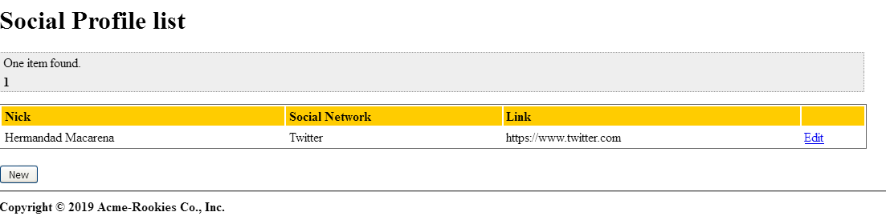

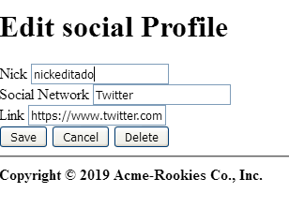

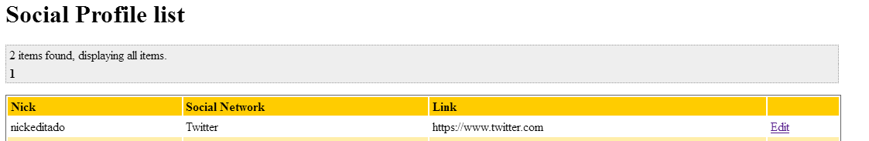

Tests

|  |  |
| --- | --- |
| **Test 001** | |
| **Description** | An actor can edit his social profile. We edit with valid data. |
| **Expected** | The system must return to a view where shows a list of social profiles owned by the logged actor, including the edited social profile. |
| **Outcome** |  |
| **Notes** |  |

|  |  |
| --- | --- |
| **Test 002** | |
| **Description** | Click on “Save” button leaving all the fields blank |
| **Expected** |  |
| **Outcome** |  |
| **Notes** |  |

|  |  |
| --- | --- |
| **Test 003** | |
| **Description** | An actor tries to fill the form with non-valid data |
| **Expected** |  |
| **Outcome** |  |
| **Notes** |  |

|  |  |
| --- | --- |
| **Test 004** | |
| **Description** | Click on “cancel” button. |
| **Expected** | The system must return to the list of problems |
| **Outcome** |  |
| **Notes** |  |

|  |  |
| --- | --- |
| **Test 005** | |
| **Description** | An actor that does not own a problem or a non-authenticated actor tries to access to the edit form by URL |
| **Expected** | The system must return the user to the index page. |
| **Outcome** |  |
| **Notes** |  |

# Use case UC23 Delete a social profile.

Description

An authenticated actor can delete his social profiles

Access

Login > Main menu > Profile > Social profiles > Edit > Delete

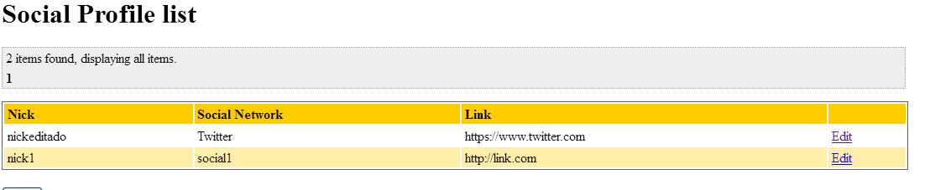



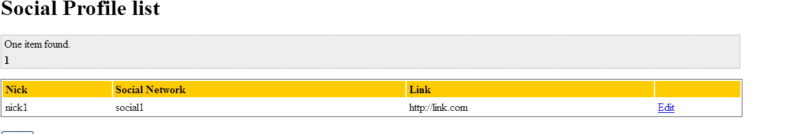

Tests

|  |  |
| --- | --- |
| **Test 001** | |
| **Description** | An actor can delete his social profiles. |
| **Expected** | The system must return to a view where shows a list of social profiles owned by the logged actor, without the deleted one. |
| **Outcome** |  |
| **Notes** |  |

# Use case UC24 List sponsorships.

Before testing

We will use sponsor1/sponsor1 and admin/admin to log into the system. We will use this user account to make testing from UC24-UC25

Description

An authenticated sponsor/admin can list his/her sponsorships.

Access

Login > Main menu > Sponsorships

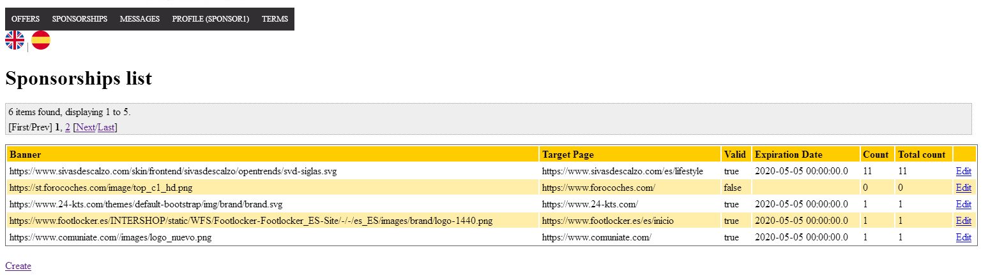

Tests

|  |  |
| --- | --- |
| **Test 001** | |
| **Description** | A user logged as sponsor or admin can list sponsorships. |
| **Expected** | The system must return to a view where shows a list of sponsorships owned by the logged actor(sponsor) or the new sponsorship that are yet to validate(admin). |
| **Outcome** |  |
| **Notes** |  |

# Use case UC25 Create a sponsorship.

Before testing

We will use sponsor1/sponsor1 and admin/admin to log into the system. We will use this user account to make testing from UC25-UC26

Description

An authenticated provider can create a sponsorship.

Access

Login > Main menu > Sponsorships > Create > Save



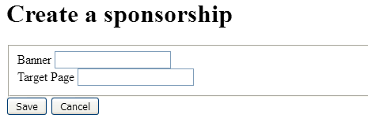

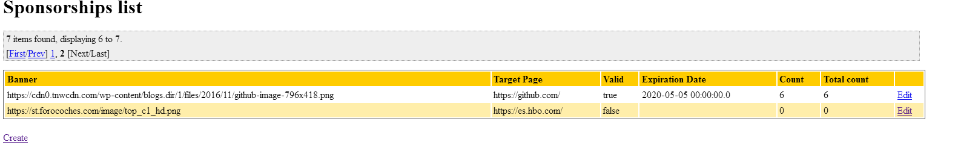

Tests

|  |  |
| --- | --- |
| **Test 001** | |
| **Description** | A user can create a sponsorship. We fill the banner image and the target page fields with an URL. |
| **Expected** | The system must return to a view where shows a list of sponsorships owned by the logged actor, including the new sponsorship created. |
| **Outcome** |  |
| **Notes** |  |

|  |  |
| --- | --- |
| **Test 002** | |
| **Description** | A user logged as sponsor can create a sponsorship. We fill the banner image and the target page fields not valid values. |
| **Expected** | The system must return to the create view with the errors in the form. |
| **Outcome** |  |
| **Notes** |  |

|  |  |
| --- | --- |
| **Test 003** | |
| **Description** | Click on “cancel” button. |
| **Expected** | The system must return to the list of sponsorships. |
| **Outcome** |  |
| **Notes** |  |

# Use case UC26 Edit a sponsorship.

Description

An authenticated admin can validate the new sponsorships created on the system.

Access

*Login > Main menu > Sponsorships > Edit > Save(Accept)*

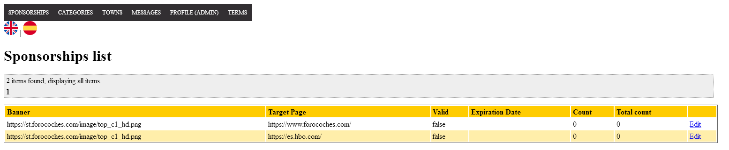

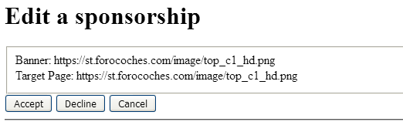

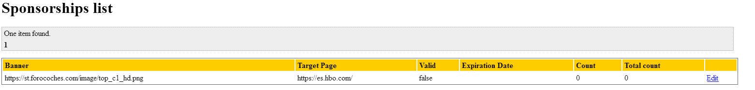

Tests

|  |  |
| --- | --- |
| **Test 001** | |
| **Description** | An admin can validate a sponsorship by accepting the sponsorship |
| **Expected** | The system must return to a view where shows a list of sponsorships that are not validated without the sponsorship modified. |
| **Outcome** |  |
| **Notes** |  |

|  |  |
| --- | --- |
| **Test 002** | |
| **Description** | An admin can decline a sponsorship by declining the sponsorship in the form and deleting it from the system. |
| **Expected** | The system must return to a view where shows a list of sponsorships that are not validated without the sponsorship modified. |
| **Outcome** |  |
| **Notes** |  |

# Use case UC27 Delete a sponsorship.

Description

An authenticated sponsor can delete his/her sponsorship .

Access

Login > Main menu > Sponsorships > Edit > Delete

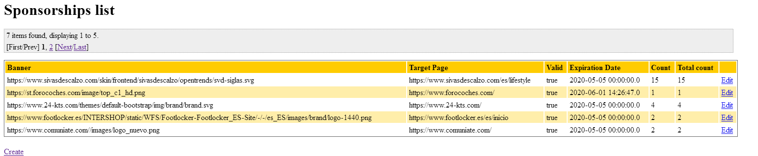

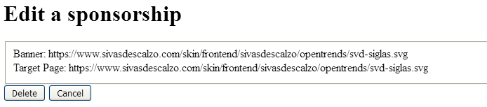

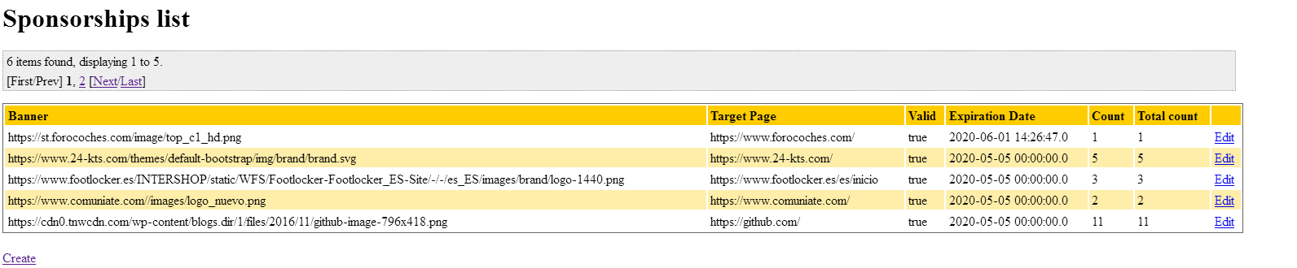

Tests

|  |  |
| --- | --- |
| **Test 001** | |
| **Description** | A user can delete a sponsorship if he/she pushes the button “Delete” on the edit. |
| **Expected** | The system must return to a view where shows a list of sponsorships owned by the logged actor, without the sponsorship deleted. |
| **Outcome** |  |
| **Notes** |  |

# Use case UC28 List fares.

Before testing

We will use carrier1/carrier1 to log into the system. We will use this user account to make testing from UC28-UC31

Description

An authenticated carrier can list his/her fares.

Access

Login > Main menu > My fares

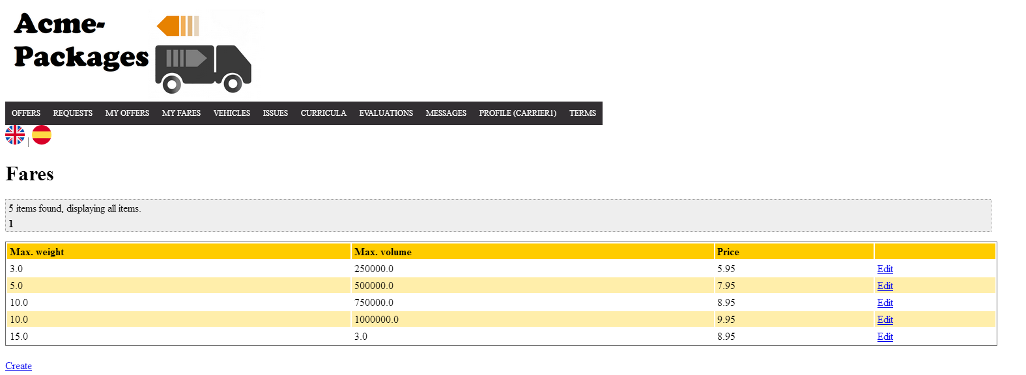

Tests

|  |  |
| --- | --- |
| **Test 001** | |
| **Description** | A user logged as carrier can list fares. |
| **Expected** | The system must return to a view where shows a list of fares owned by the logged carrier. |
| **Outcome** |  |
| **Notes** |  |

|  |  |
| --- | --- |
| **Test 001** | |
| **Description** | A user can list the fares from a public offer. |
| **Expected** | The system must return to a view where shows a list of fares that are in the selected offer. |
| **Outcome** |  |
| **Notes** |  |

# Use case UC29 Create a fare.

Before testing

We will use carrier/carrier1 to log into the system. We will use this user account to make testing from UC29-UC31

Description

An authenticated provider can create a fare.

Access

Login > Main menu > My Fares > Create > Save



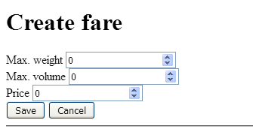

Tests

|  |  |
| --- | --- |
| **Test 001** | |
| **Description** | A carrier can create a fare. We fill weight, height and the price in the form. |
| **Expected** | The system must return to a view where shows a list of fares owned by the carrier with the new created fare. |
| **Outcome** |  |
| **Notes** |  |

|  |  |
| --- | --- |
| **Test 002** | |
| **Description** | A carrier can create a fare. We fill the form with invalid data. |
| **Expected** | The system must return to the create view with the errors in the form. |
| **Outcome** |  |
| **Notes** |  |

|  |  |
| --- | --- |
| **Test 003** | |
| **Description** | Click on “cancel” button. |
| **Expected** | The system must return to the list of fares. |
| **Outcome** |  |
| **Notes** |  |

# Use case UC30 Edit a fare.

Description

An authenticated carrier can edit his/her fares.

Access

*Login > Main menu > My Fares > Edit > Save*



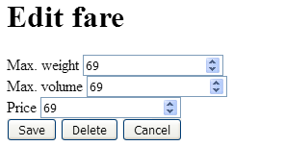

Tests

|  |  |
| --- | --- |
| **Test 001** | |
| **Description** | A carrier can edit his/her fares. |
| **Expected** | The system must return to the list of the owned fares by the carrier with the changes applied. |
| **Outcome** |  |
| **Notes** |  |

|  |  |
| --- | --- |
| **Test 002** | |
| **Description** | Click on the “Save” button with invalid data. |
| **Expected** | The system must return to the edit view with the errors in the form. |
| **Outcome** |  |
| **Notes** |  |

# Use case UC31 Delete a fare.

Description

An authenticated carrier can delete his/her fares .

Access

Login > Main menu > My Fares > Edit > Delete





Tests

|  |  |
| --- | --- |
| **Test 001** | |
| **Description** | A user can delete a fare if he/she pushes the button “Delete” on the edit. |
| **Expected** | The system must return to a view where shows a list of fares owned by the logged actor, without the fare deleted. |
| **Outcome** |  |
| **Notes** |  |

# Use case UC32 List traverse towns.

Before testing

We will use carrier1/carrier1 to log into the system. We will use this user account to make testing from UC32-UC35

Description

A user can list his/her the traverse towns from an offer that is not in final mode.

Access

Login > Main menu > Offers > Display offer

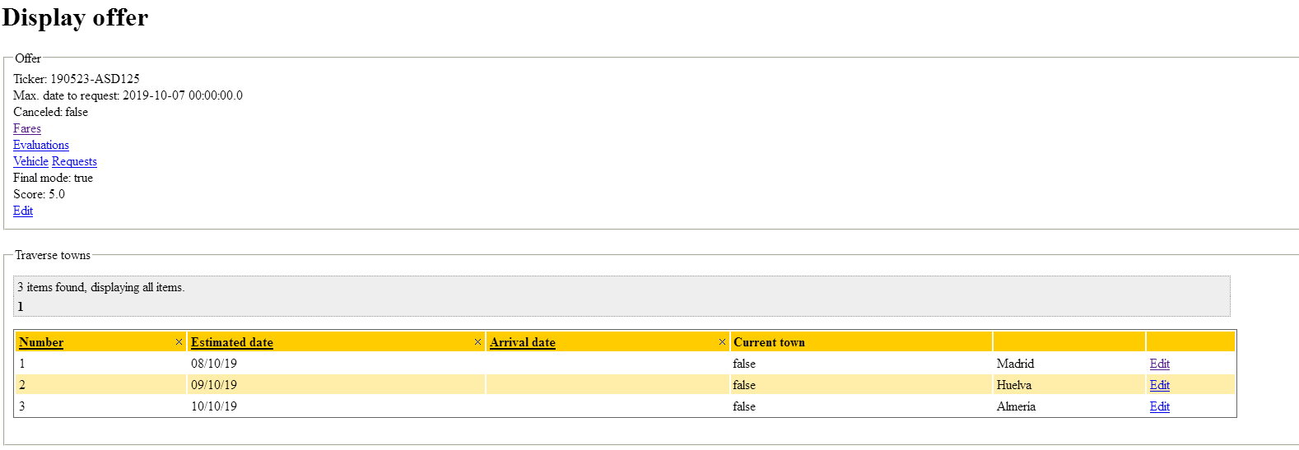

Tests

|  |  |
| --- | --- |
| **Test 001** | |
| **Description** | A user logged can list the traverse towns form an offer. |
| **Expected** | The system must return to a view where shows the offer is displayed and the list of the traverse towns that are in it. |
| **Outcome** |  |
| **Notes** |  |

# Use case UC33 Create a traverse town.

Before testing

We will use carrier/carrier1 to log into the system. We will use this user account to make testing from UC33-UC35

Description

An authenticated carrier can create a traverse town to an offer that is not in final mode.

Access

Login > Main menu > My Offers > Display Offer > Create > Save

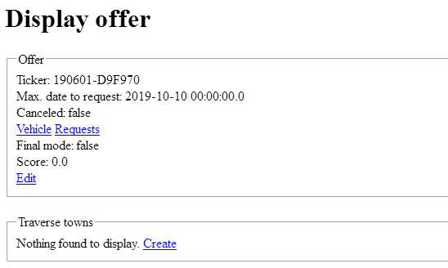

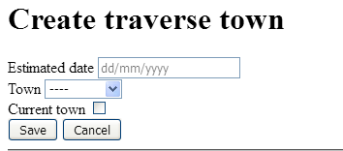

Tests

|  |  |
| --- | --- |
| **Test 001** | |
| **Description** | A carrier can create a traverse town. We fill the estimated date, the town and if it is the current town. |
| **Expected** | The system must return to a view where shows a list of traverse towns that belong to the offer with the new traverse town in it. |
| **Outcome** |  |
| **Notes** |  |

|  |  |
| --- | --- |
| **Test 002** | |
| **Description** | A carrier can create a fare. We fill the form with invalid data |
| **Expected** | The system must return to the create view with the errors in the form. |
| **Outcome** |  |
| **Notes** |  |

|  |  |
| --- | --- |
| **Test 003** | |
| **Description** | Click on “cancel” button. |
| **Expected** | The system must return to the display of the offer. |
| **Outcome** |  |
| **Notes** |  |

# Use case UC34 Edit a traverse town.

Description

An authenticated carrier can edit his/her traverse towns from an offer that is not in final mode.

Access

*Login > Main menu > My Fares > Edit > Save*

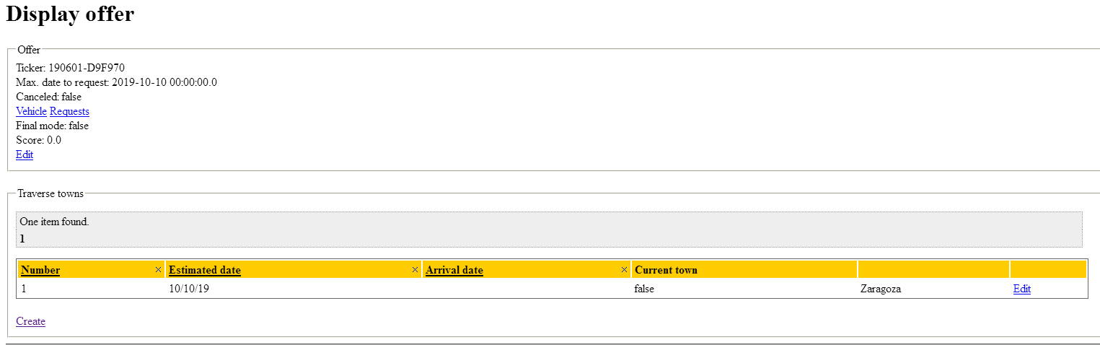

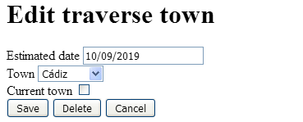

Tests

|  |  |
| --- | --- |
| **Test 001** | |
| **Description** | A carrier can edit his/her traverse towns from one of his offers. |
| **Expected** | The system must return to the display of the offer with the list of traverse towns with the changes applied. |
| **Outcome** |  |
| **Notes** |  |

|  |  |
| --- | --- |
| **Test 002** | |
| **Description** | Click on the “Save” button with invalid data. |
| **Expected** | The system must return to the edit view with the errors in the form. |
| **Outcome** |  |
| **Notes** |  |
| **Test 003** | |
| **Description** | Carrier tries to save the traverse town with a date after another estimates date |
| **Expected** | The system must return to the edit view with the errors in the form with the custom message. |
| **Outcome** |  |
| **Notes** |  |

|  |  |
| --- | --- |
| **Test 004** | |
| **Description** | Carrier tries to save the traverse town with a date before the last day to request from the offer. |
| **Expected** | The system must return to the edit view with the errors in the form with the custom message. |
| **Outcome** |  |
| **Notes** |  |

# Use case UC35 Delete a traverse town.

Description

An authenticated carrier can delete his/her traverse towns from an offer that is not in final mode.

Access

Login > Main menu > My Fares > Edit > Delete



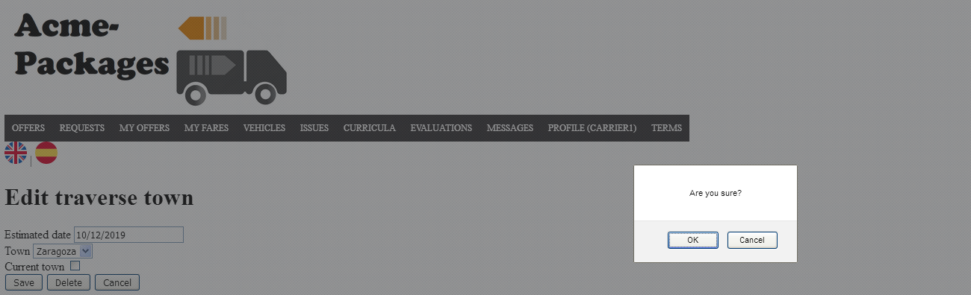

Tests

|  |  |
| --- | --- |
| **Test 001** | |
| **Description** | A user can delete a traverse town if he/she pushes the button “Delete” on the edit. |
| **Expected** | The system must return to a view of the display from the offer, without the traverse town list without the traverse town deleted. |
| **Outcome** |  |
| **Notes** |  |

# Use case UC36 List requests.

Before testing

We will use customer1/customer1 to log into the system. We will use this user account to make testing from UC36-UC39

Description

A user can list the requests from an offer and his/her request created(carriers and customers).

Access

Login > Main menu > Offers > Display offer

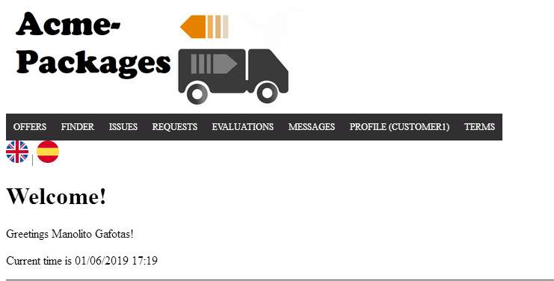

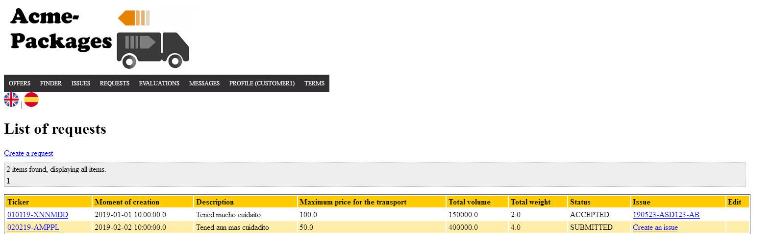

Tests

|  |  |
| --- | --- |
| **Test 001** | |
| **Description** | A user logged as customer can list his/her requests |
| **Expected** | The system must return to a view where shows the list of requests owned by the logged actor. |
| **Outcome** |  |
| **Notes** |  |

|  |  |
| --- | --- |
| **Test 002** | |
| **Description** | A user logged as carrier can list the requests from one of his offers entering by the display of it. |
| **Expected** | The system must return to a view where shows the list of requests that belong to one of his offers. |
| **Outcome** |  |
| **Notes** |  |

# Use case UC37 Create a request.

Before testing

We will use customer1/customer1 to log into the system. We will use this user account to make testing from UC37-UC39

Description

An authenticated carrier can create a traverse town to an offer that is not in final mode.

Access

Login > Main menu > Request > Create > Save

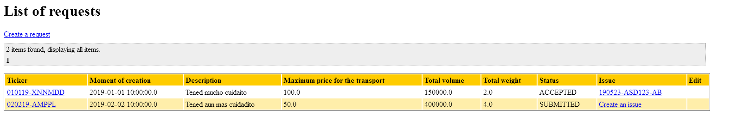

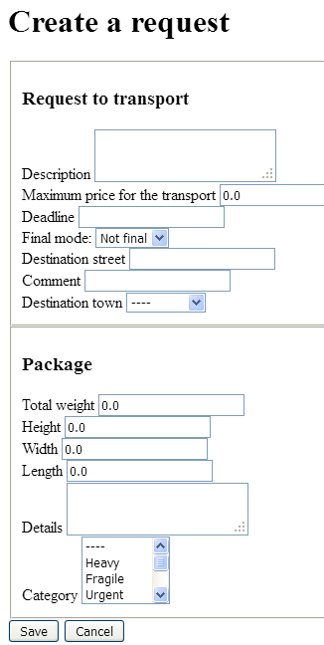

Tests

|  |  |
| --- | --- |
| **Test 001** | |
| **Description** | A customer can create a Request. We fill the form with valid data and a valid package. |
| **Expected** | The system must return to a view where the new request is displayed. |
| **Outcome** |  |
| **Notes** |  |

|  |  |
| --- | --- |
| **Test 002** | |
| **Description** | A carrier can create a fare. We fill the form with all blank values |
| **Expected** | The system must return to the create view with the errors in the form. |
| **Outcome** |  |
| **Notes** |  |

|  |  |
| --- | --- |
| **Test 003** | |
| **Description** | Click on “cancel” button. |
| **Expected** | The system must return to the list of requests. |
| **Outcome** |  |
| **Notes** |  |

# Use case UC38 Edit a request.

Description

An authenticated customer can edit his/her request if they are not in final mode.

Access

*Login > Main menu > Requests > Edit > Save*

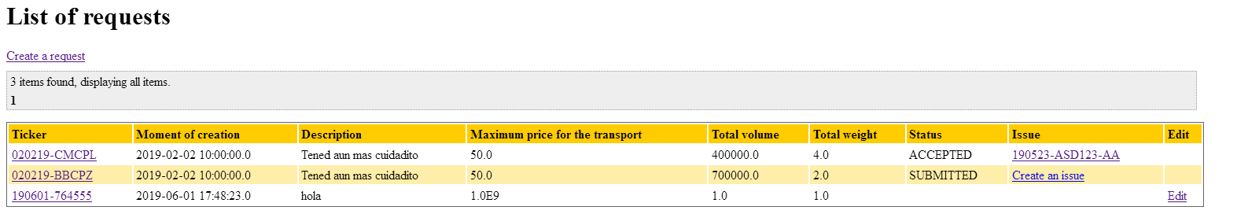

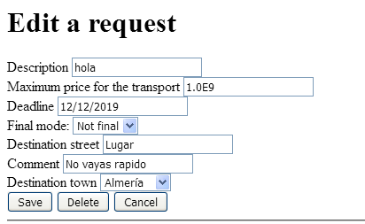

Tests

|  |  |
| --- | --- |
| **Test 001** | |
| **Description** | A customer can edit his/her requests. |
| **Expected** | The system must return to the display of the request with all the changes applied. |
| **Outcome** |  |
| **Notes** |  |

|  |  |
| --- | --- |
| **Test 002** | |
| **Description** | Click on the “Save” button with invalid data. |
| **Expected** | The system must return to the edit view with the errors in the form. |
| **Outcome** |  |
| **Notes** |  |

|  |  |
| --- | --- |
| **Test 003** | |
| **Description** | The customer applies for an offer that fits the parameters. |
| **Expected** | The system must to the list of requests and if it was not in final mode, it will be changed to final and the status will be “SUBMITTED”. |
| **Outcome** |  |
| **Notes** |  |

|  |  |
| --- | --- |
| **Test 004** | |
| **Description** | The carrier that has the offer that was selected by or more request can decide the ones that goes with his offer.(we log as carrier1/carrier1 to do this test) |
| **Expected** | The system must show the list of requests of the selected offer and with the changes applied to the status to the request(ACCEPTED OR REJECTED). |
| **Outcome** |  |
| **Notes** |  |

# Use case UC39 Delete a request.

Description

An authenticated customer can delete his/her request that are not in final mode.

Access

Login > Main menu > Requests > Edit > Delete

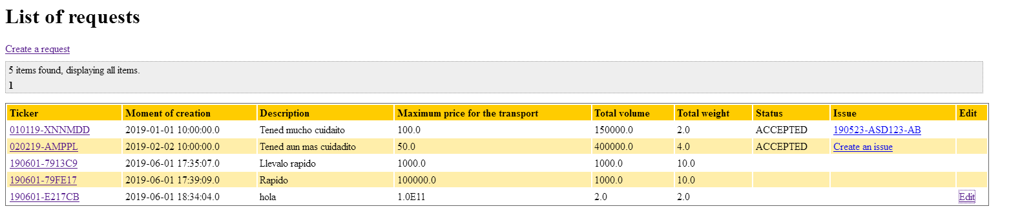

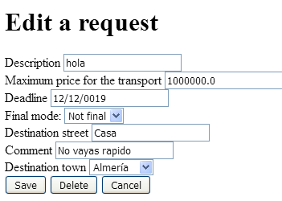

Tests

|  |  |
| --- | --- |
| **Test 001** | |
| **Description** | A user logged as customer can delete a request if he/she pushes the button “Delete” on the edit. |
| **Expected** | The system must return to the list view of request from the logged customer without the request that has been deleted. |
| **Outcome** |  |
| **Notes** |  |

# Use case UC40 Manage towns

Description

An admin can manage the towns of the system.

Access

We need to log-in with the admin and go to the following section:



Tests

|  |  |
| --- | --- |
| **Test 001** | |
| **Description** | Click in the town section, we will see the town list |
| **Expected** |  |
| **Outcome** |  |
| **Notes** |  |

|  |  |
| --- | --- |
| **Test 002** | |
| **Description** | Now, we click in the create button and we send the formulary in blank |
| **Expected** |  |
| **Outcome** |  |
| **Notes** |  |

|  |  |
| --- | --- |
| **Test 003** | |
| **Description** | Send the formulary with valid data |
| **Expected** | The town is created on the system |
| **Outcome** |  |
| **Notes** |  |

|  |  |
| --- | --- |
| **Test 004** | |
| **Description** | Click in the edit button of the created town and change the name |
| **Expected** | The name was changed without problem |
| **Outcome** |  |
| **Notes** |  |

|  |  |
| --- | --- |
| **Test 005** | |
| **Description** | Click in the edit button of the created town and delete it |
| **Expected** | The town is deleted of the system |
| **Outcome** |  |
| **Notes** |  |

# Use case UC41 Management of issues

Description

A customer can create an issue to solve a problem with a request. An auditor can help to solve the problem.

Access

We need to log-in with customer1/customer1 and go to the following section:

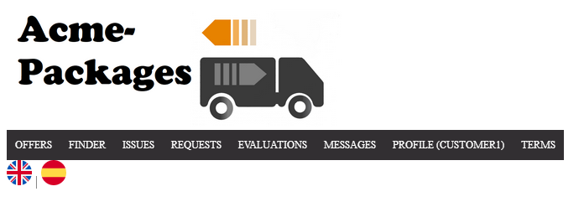

Tests

|  |  |
| --- | --- |
| **Test 001** | |
| **Description** | Click in the request section, we will see the request list and an option to create an issue. Click in create an issue and send the formulary in blank |
| **Expected** |  |
| **Outcome** |  |
| **Notes** |  |

|  |  |
| --- | --- |
| **Test 002** | |
| **Description** | Now, we send the formulary with valid data |
| **Expected** | The issue is created and we see the display |
| **Outcome** |  |
| **Notes** |  |

|  |  |
| --- | --- |
| **Test 003** | |
| **Description** | Click in the delete button. |
| **Expected** | The issue is deleted from the system |
| **Outcome** |  |
| **Notes** |  |

|  |  |
| --- | --- |
| **Test 004** | |
| **Description** | Click in the issues button on the navbar |
| **Expected** |  |
| **Outcome** |  |
| **Notes** |  |

|  |  |
| --- | --- |
| **Test 005** | |
| **Description** | Click in the ticker and the system must show the display |
| **Expected** |  |
| **Outcome** |  |
| **Notes** |  |

|  |  |
| --- | --- |
| **Test 006** | |
| **Description** | Log-in with an auditor and go to the issue section in the navbar, there are an issue, click in the assign button |
| **Expected** | A list of the issues assigned to the auditor, included the one that we just assign. |
| **Outcome** |  |
| **Notes** |  |

|  |  |
| --- | --- |
| **Test 007** | |
| **Description** | Click in the ticker of the first issue, we will see the display with a comment form, write a comment |
| **Expected** |  |
| **Outcome** |  |
| **Notes** |  |

|  |  |
| --- | --- |
| **Test 008** | |
| **Description** | Left the comment form in blank and send it |
| **Expected** |  |
| **Outcome** |  |
| **Notes** |  |

|  |  |
| --- | --- |
| **Test 009** | |
| **Description** | Click in the close issue button |
| **Expected** |  |
| **Outcome** |  |
| **Notes** |  |

# Use case UC42 manage professional records

Description

When a carrier wants to register the professional records of his or her curricula

Access

We need to log-in with a carrier, carrier1/carrier1 and go to the curricula section in the navbar and click in the name of the first curriculum

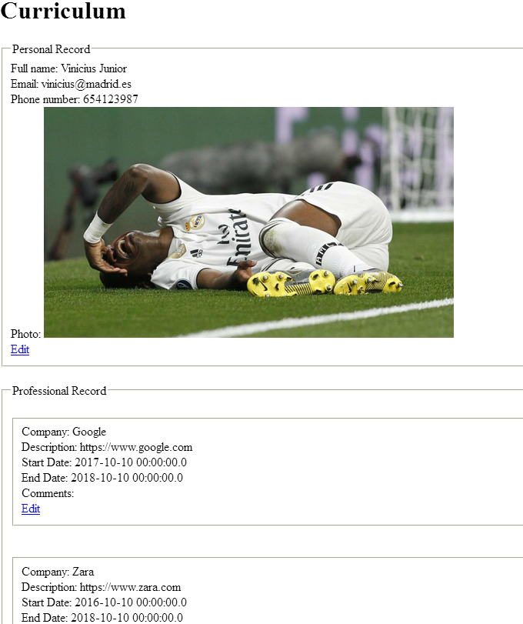

Tests

|  |  |
| --- | --- |
| **Test 001** | |
| **Description** | In the professional record section; click in the add button and left the formulary in blank, send it. |
| **Expected** |  |
| **Outcome** |  |
| **Notes** |  |

|  |  |
| --- | --- |
| **Test 002** | |
| **Description** | Now, write a company name and send it again |
| **Expected** | The system redirects us to the curriculum display with the new record saved. |
| **Outcome** |  |
| **Notes** |  |

|  |  |
| --- | --- |
| **Test 003** | |
| **Description** | Click in the edit button of the created record, write a comment and change the company name |
| **Expected** | The system gives us back to the display with the changes in the record |
| **Outcome** |  |
| **Notes** |  |

|  |  |
| --- | --- |
| **Test 004** | |
| **Description** | Click in the edit button of the created record, and then in the delete button |
| **Expected** | The system redirects us to the curriculum display and the record was deleted |
| **Outcome** |  |
| **Notes** |  |

# Use case UC43 Display dashboard.

Description

An admin can display the dashboard

Access

Login > Main menu > Profile > Dashboard

Tests

|  |  |
| --- | --- |
| **Test 001** | |
| **Description** | An admin can display the dashboard. |
| **Expected** | The system must return to a view with the dashboard.  https://i.gyazo.com/3180fa8448e33f48b5b18036f3090bef.png  https://i.gyazo.com/80deaf5da67adca2c352207ec57abacb.png  https://i.gyazo.com/7d184a110deecc0e0f734222237aa086.png |
| **Outcome** |  |
| **Notes** |  |

|  |  |
| --- | --- |
| **Test 002** | |
| **Description** | A non admin or a non-authenticated actor tries to access to the dashboard by URL. |
| **Expected** | The system must return to index view or the login page respectively. |
| **Outcome** |  |
| **Notes** |  |

# Use case UC44 Calculate spammers, compute carrier score, send notification to sponsor about their sponsorships and invalid undated sponsorships.

Description

An admin can calculate spammers, compute carrier score, send notification to sponsors about their sponsorships and invalid undated sponsorships.

Access

Login > Main menu > Profile > Dashboard

Tests

|  |  |
| --- | --- |
| **Test 001** | |
| **Description** | An admin calculates spammers. |
| **Expected** | The system must calculate spammers and return the dashboard. |
| **Outcome** |  |
| **Notes** |  |

|  |  |
| --- | --- |
| **Test 002** | |
| **Description** | An admin computes carrier score. |
| **Expected** | The system must calculate carrier score, updating them on their profiles, and return to the dashboard. |
| **Outcome** |  |
| **Notes** |  |

|  |  |
| --- | --- |
| **Test 003** | |
| **Description** | An admin sends notification to sponsors. |
| **Expected** | The system must send a notification to all the sponsors with valid sponsorships and communicate them how many times their sponsorships has been shown and how much money they are going to be charged.  https://i.gyazo.com/25ca38b8116781900c31ae1c1b701975.png  https://i.gyazo.com/ace40c714a0c186032b8d7c4046659d7.png |
| **Outcome** |  |
| **Notes** |  |

|  |  |
| --- | --- |
| **Test 004** | |
| **Description** | An admin invalid undated sponsorship. |
| **Expected** | The system must set all sponsorships that are undated (< Current Time) to invalid. |
| **Outcome** |  |
| **Notes** |  |

# Use case UC45 Ban actors

Description

An admin can ban suspicious actors (Spammers)

Access

Login > Main menu > Profile > Suspicious actor

Tests

|  |  |
| --- | --- |
| **Test 001** | |
| **Description** | An admin can ban suspicious actor. |
| **Expected** | https://i.gyazo.com/9ec3b0ab2a9771a8e64743ce0eb99780.png |
| **Outcome** |  |
| **Notes** |  |

|  |  |
| --- | --- |
| **Test 002** | |
| **Description** | An admin can unban banned actors. |
| **Expected** | https://i.gyazo.com/518d8ddc44a6835b5373cd4b160d48b7.png |
| **Outcome** |  |
| **Notes** |  |

# Use case UC46 Finder

Description

A customer has a finder with some filters that help him or her to find offers.

Access

We need to log-in with a customer user (“customer1” “customer1” for example) and go to the following section:

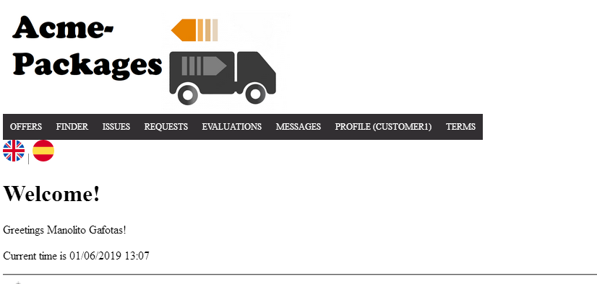

Tests

|  |  |
| --- | --- |
| **Test 001** | |
| **Description** | You must not fill any filter and click in the search button. |
| **Expected** | All the offers must be retrieves.  https://i.gyazo.com/fa121736d3f6afe95faea855e4384b7b.png |
| **Outcome** |  |
| **Notes** |  |

|  |  |
| --- | --- |
| **Test 002** | |
| **Description** | You must fill the town fill, for example with “madrid”, and click in the search button. |
| **Expected** | Offers with “madrid” are given.  https://i.gyazo.com/9820393d268045f03a63a6acb431c2f9.png |
| **Outcome** |  |
| **Notes** |  |

|  |  |
| --- | --- |
| **Test 003** | |
| **Description** | You must fill the max date field, for example with “04/04/2020”, and click in the search button. |
| **Expected** | Offers with max date lower than the one in the field must be shown.  https://i.gyazo.com/5446588ce96d0363ee7b7be745b1c6d8.png |
| **Outcome** |  |
| **Notes** |  |

|  |  |
| --- | --- |
| **Test 004** | |
| **Description** | You must fill the min date field, for example with “04/04/2020”, and click in the search button. |
| **Expected** | Offers with max date higher than the one in the field must be shown.  https://i.gyazo.com/662ea23d0857d348ff3d149fb162310f.png |
| **Outcome** |  |
| **Notes** |  |

|  |  |
| --- | --- |
| **Test 005** | |
| **Description** | You must fill the weight field, for example with “19”, and click in the search button. |
| **Expected** | Offers that allow that weight must be shown.  https://i.gyazo.com/3db1f257abd4313ca77446c22f942028.png |
| **Outcome** |  |
| **Notes** |  |

|  |  |
| --- | --- |
| **Test 006** | |
| **Description** | You must fill all the filters, search, and then click in the clear button. |
| **Expected** | All the filters were cleared. |
| **Outcome** |  |
| **Notes** |  |

|  |  |
| --- | --- |
| **Test 007** | |
| **Description** | You must fill the volume field, for example with “50”, and click on the search button. |
| **Expected** | The system must return the offers that allow that volume.  https://i.gyazo.com/33e963a120a140cccec2235c6bf9160f.png |
| **Outcome** |  |
| **Notes** |  |

|  |  |
| --- | --- |
| **Test 008** | |
| **Description** | You must select a category and click on the search button |
| **Expected** | The system should return the offers with that category  https://i.gyazo.com/ddd2701edbd17fdd024b1168d81dbc03.png |
| **Outcome** |  |
| **Notes** |  |

|  |  |
| --- | --- |
| **Test 009** | |
| **Description** | You must fill the must price field, for example “4” ,and click on search |
| **Expected** | The system must return the offers that have fares with a price lower than the one in the field.  https://i.gyazo.com/c349c239ebaf36e7489ff657ae6bd7e7.png |
| **Outcome** |  |
| **Notes** |  |

|  |  |
| --- | --- |
| **Test 010** | |
| **Description** | You must click in the cancel button. |
| **Expected** | The system gives us to the welcome page. |
| **Outcome** |  |
| **Notes** |  |

# Use case UC47 Register as user

Description

An unauthenticated actor wants to register to the system; he or she fills a form with personal data, user account data and extra data depending the type of user selected.

Access

Main Menu > Sign-up.

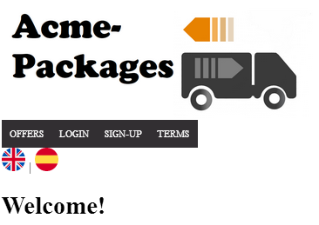

Tests

|  |  |
| --- | --- |
| **Test 001** | |
| **Description** | The form must not be filled, the selected type of actor is carrier |
| **Expected** | The system must ask us to confirm the phone.  The system must return the form with the following errors: https://i.gyazo.com/01c5f894bee2d3cbebbb361b2e12dfbb.png |
| **Outcome** |  |
| **Notes** |  |

|  |  |
| --- | --- |
| **Test 002** | |
| **Description** | The form must not be filled, the selected type of actor is customer |
| **Expected** | The system must ask us to confirm the phone.  The system must return the form with the following errors:  https://i.gyazo.com/201fa12332f0b64bf30c0d74c031e579.png |
| **Outcome** |  |
| **Notes** |  |

|  |  |
| --- | --- |
| **Test 003** | |
| **Description** | The form must not be filled, the selected type of actor is sponsor. |
| **Expected** | The system must ask us to confirm the phone.  The system must return the form with the following errors:  https://i.gyazo.com/9172af1b59e53cf1f578ede74069f8ca.png |
| **Outcome** |  |
| **Notes** |  |

|  |  |
| --- | --- |
| **Test 004** | |
| **Description** | The form must be filled with correct data to register as a carrier |
| **Expected** | After confirm the phone, the system give us to the welcome page, and now we are able to log-in with the created user. |
| **Outcome** |  |
| **Notes** |  |

|  |  |
| --- | --- |
| **Test 005** | |
| **Description** | The form must be filled with correct data to register as a customer |
| **Expected** | After confirm the phone, the system give us to the welcome page, and now we are able to log-in with the created user. |
| **Outcome** |  |
| **Notes** |  |

|  |  |
| --- | --- |
| **Test 006** | |
| **Description** | The form must be filled with correct data to register as sponsor |
| **Expected** | After confirm the phone, the system give us to the welcome page, and now we are able to log-in with the created user. |
| **Outcome** |  |
| **Notes** |  |

|  |  |
| --- | --- |
| **Test 007** | |
| **Description** | The form must be filled with correct data but the password and confirm password must not be the same: |
| **Expected** | The system must ask us to confirm the phone and this error must be shown:  https://i.gyazo.com/62ee12f7eefd1fbf74c2301a7b70cb67.png |
| **Outcome** |  |
| **Notes** |  |

# Use case UC48 Create a user being an administrator

Description

An administrator wants to create new administrators or auditors; he or she fills a form with personal data, user account data and extra data depending the type of user selected.

Access

We need to log-in with “admin” “admin” and then go to the profile section and “Create actor”.

|  |  |
| --- | --- |
| **Test 001** | |
| **Description** | The form must not be filled, the selected type of actor is administrator. |
| **Expected** | The system must ask us to confirm the phone.  The system must return the form with the following errors:  https://i.gyazo.com/50e4a5a8470ec1318bbbc034ba045b34.png |
| **Outcome** |  |
| **Notes** |  |

|  |  |
| --- | --- |
| **Test 002** | |
| **Description** | The form must not be filled, the selected type of actor is auditor. |
| **Expected** | The system must ask us to confirm the phone.  The system must return the form with the following errors:  https://i.gyazo.com/0fecd158a367c2663dc660fff88b3b61.png |
| **Outcome** |  |
| **Notes** |  |

|  |  |
| --- | --- |
| **Test 003** | |
| **Description** | The form must be filled with a different password in the Password field and the Confirm password field. |
| **Expected** | The system must ask us to confirm the phone.  The system must return the form with the following errors: |
| **Outcome** |  |
| **Notes** |  |

|  |  |
| --- | --- |
| **Test 005** | |
| **Description** | The form must be filled with correct data to register as administrator |
| **Expected** | After confirm the phone, the system give us to the welcome page, and now we are able to log-in with the created user. |
| **Outcome** |  |
| **Notes** |  |

|  |  |
| --- | --- |
| **Test 006** | |
| **Description** | The form must be filled with correct data to register as auditor |
| **Expected** | After confirm the phone, the system give us to the welcome page, and now we are able to log-in with the created user. |
| **Outcome** |  |
| **Notes** |  |

# Use case UC49 Display personal data

Description

A logged user must be able to display his or her personal data.

Access

We need to log-in with the appropriate user and go to the following section:

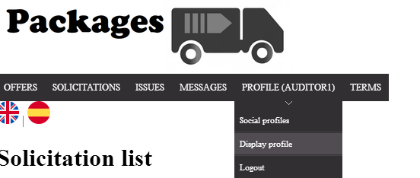

Tests

|  |  |
| --- | --- |
| **Test 001** | |
| **Description** | Log in with any user and display the profile |
| **Expected** | https://i.gyazo.com/775d820b23477fa3edce63995f41a0a1.png |
| **Outcome** |  |
| **Notes** |  |

# Use case UC50 Manage personal data

Description

When a logged user wants to manage his or her personal data.

Access

We need to log-in with the appropriate user and go to the following section:



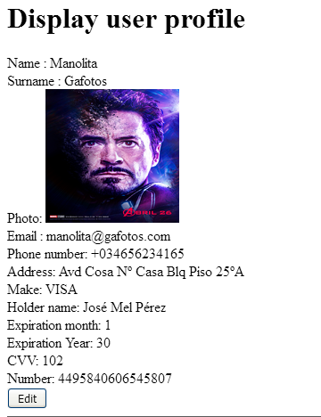

Tests

|  |  |
| --- | --- |
| **Test 001** | |
| **Description** | Trying to edit the profile with all the fields blank |
| **Expected** | https://i.gyazo.com/832eb00839fdee13d80164d0a5fbf1f8.png |
| **Outcome** |  |
| **Notes** |  |

|  |  |
| --- | --- |
| **Test 002** | |
| **Description** | You must make some legal changes on the fields, for example, change the name to “nameTest”, the email to [test@test.com](mailto:test@test.com) and submit the form. |
| **Expected** | The system gives us back to the display and the changes were made. |
| **Outcome** |  |
| **Notes** |  |

|  |  |
| --- | --- |
| **Test 003** | |
| **Description** | Click in the cancel button. |
| **Expected** | The system gives us back to the display without changes. |
| **Outcome** |  |
| **Notes** |  |

|  |  |
| --- | --- |
| **Test 004** | |
| **Description** | Click in the export data button. |
| **Expected** | A Json with the data of the actor:  https://i.gyazo.com/0c6cbcf44946182cbc071d2353018e67.png |
| **Outcome** |  |
| **Notes** |  |

|  |  |
| --- | --- |
| **Test 005** | |
| **Description** | Click in the delete button |
| **Expected** | A confirmation if we are sure to delete and then the system gives us back to the welcome page, our user account was deleted from the system. |
| **Outcome** |  |
| **Notes** |  |

# Use case UC51 List of vehicles

Description

Carrier of the system can list their vehicles.

Access

By clicking in the field “Vehicles” in the navigation bar when you’re a logged as a carrier

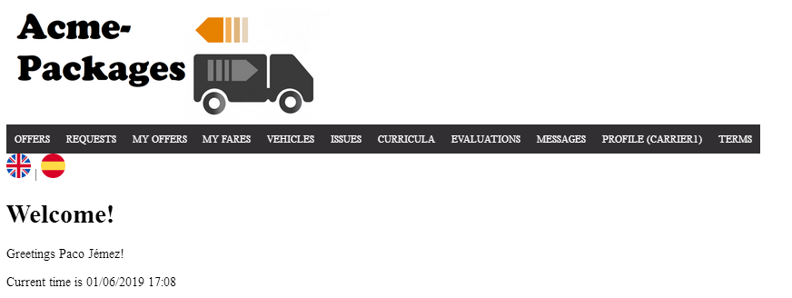

Tests

|  |  |
| --- | --- |
| **Test 001** | |
| **Description** | A logged carrier tries to list his vehicles |
| **Expected** | The system shows the carrier vehicles  https://i.gyazo.com/f2ec165c03864c45b4c538d260517c38.png |
| **Outcome** |  |
| **Notes** |  |

|  |  |
| --- | --- |
| **Test 002** | |
| **Description** | A non-carrier or a nonnon-logged actor tries to access to the list of vehicles by URL |
| **Expected** | The system shouldn’t show the list of vehicles or the system must return to the login page respectively. |
| **Outcome** |  |
| **Notes** |  |

# Use case UC52 Display of vehicles

Description

Every auditor of the system can display his/her vehicles. Carriers can display the vehicles of their solicitations.

Access

By clicking in the plate of a vehicle inside the listing page.

Tests

|  |  |
| --- | --- |
| **Test 001** | |
| **Description** | An auditor displays one of his vehicles |
| **Expected** | https://i.gyazo.com/54613aca765da048f0f94c153d496b49.png |
| **Outcome** |  |
| **Notes** |  |

|  |  |
| --- | --- |
| **Test 002** | |
| **Description** | A carrier display one of the vehicles of his solicitations. |
| **Expected** | https://i.gyazo.com/202f72e3dcaf797b73ab498320159d94.png |
| **Outcome** |  |
| **Notes** |  |

|  |  |
| --- | --- |
| **Test 003** | |
| **Description** | Wrong actor tries to display a vehicle by URL. |
| **Expected** | https://i.gyazo.com/d72f3a5840962b3eebd139365c3ba925.png |
| **Outcome** |  |
| **Notes** |  |

# Use case UC53 Manage of vehicles

Description

The carrier of the system can manage their vehicles

Access

A logged carrier can manage his vehicles through the list and display of vehicles:

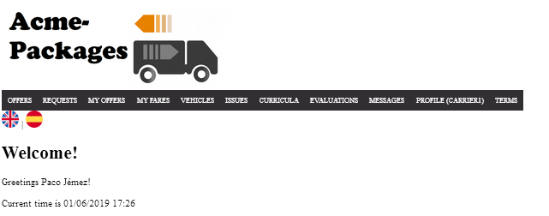

Tests

|  |  |
| --- | --- |
| **Test 001** | |
| **Description** | A logged carrier tries to create a vehicle without filling the fields |
| **Expected** | https://i.gyazo.com/54db5c134d065a67085d9b79af9a9db3.png |
| **Outcome** |  |
| **Notes** |  |

|  |  |
| --- | --- |
| **Test 002** | |
| **Description** | A logged carrier tries to create a vehicle filling the fields with correct data |
| **Expected** | The vehicle must redirect to the display of the vehicle and the new vehicle must be in the list of vehicles.  https://i.gyazo.com/9944e09a265a0cedc37dc4738adc24fc.png  https://i.gyazo.com/5c1dbf34dc29e2ac2c27c1254fb44eaf.png |
| **Outcome** |  |
| **Notes** |  |

|  |  |
| --- | --- |
| **Test 003** | |
| **Description** | A logged carrier tries to edit one of his vehicles |
| **Expected** | The system must redirect to the display of the vehicle with the updated information.  https://i.gyazo.com/37c822dbecce26ac06edeaf876c290cc.png |
| **Outcome** |  |
| **Notes** |  |

|  |  |
| --- | --- |
| **Test 006** | |
| **Description** | A logged carrier tries to delete one of his vehicles. |
| **Expected** | https://i.gyazo.com/633ccd406a45a506d367ce3a1933418d.png  The system must return to the list of vehicles and the deleted one must not be in there.  https://i.gyazo.com/a8fc10c329be3b20efb16dc6f9492c98.png |
| **Outcome** |  |
| **Notes** |  |

# Use case UC54 List of solicitations

Description

Carriers and auditors of the system can list solicitations.

Access

Carriers 🡪 By clicking in the field “Vehicles” in the navigation bar when you’re a logged as a carrier and then of the display of vehicle.

Auditor 🡪 By clicking in the field “Solicitation” and the “My solicitation” field in the navigation bar when you’re a logged as an auditor.

Tests

|  |  |
| --- | --- |
| **Test 001** | |
| **Description** | A logged carrier tries to list his solicitations for a vehicle |
| **Expected** | The system shows the list of solicitations of the vehicle with the display of the vehicle  https://i.gyazo.com/40ca89fc12ccd19090a718e4c6424f1c.png |
| **Outcome** |  |
| **Notes** |  |

|  |  |
| --- | --- |
| **Test 002** | |
| **Description** | A logged auditor lists the solicitations of the system that are not assigned. |
| **Expected** | By clicking on the “Solicitation” field the system must show a list of them:  https://i.gyazo.com/206b0ad0304fa9c301a9c730374833de.png |
| **Outcome** |  |
| **Notes** |  |

|  |  |
| --- | --- |
| **Test 003** | |
| **Description** | A logged auditor lists his solicitations |
| **Expected** | By clicking on the “My solicitation” field the system must show a list of them:  https://i.gyazo.com/196a7819743a051b22d1ec162ff6528f.png |
| **Outcome** |  |
| **Notes** |  |

# Use case UC55 Manage of solicitations

Description

The carrier and auditor of the system can manage solicitations

Access

Carrier 🡪 Through the display of vehicles can create new solicitations

Auditor 🡪 Through the “Solicitations” and “My solicitations” field in the main menu bar.

Tests

|  |  |
| --- | --- |
| **Test 001** | |
| **Description** | A logged carrier tries to create a new solicitation for one of his vehicles with correct data.  https://i.gyazo.com/131627a57a6568753f1a79cbf222f2de.png  https://i.gyazo.com/62a6c2782fe0978b8dd8946efcb3ed28.png |
| **Expected** | The solicitation must be added to the existing list:  https://i.gyazo.com/82879a26a62c8805a01529eaa0e262c5.png |
| **Outcome** |  |
| **Notes** |  |

|  |  |
| --- | --- |
| **Test 002** | |
| **Description** | A logged carrier tries to create a new solicitation for one of his vehicles without filling the fields. |
| **Expected** | https://i.gyazo.com/cd7b60a70863aec9d1dd527cbf38053f.png  This error must be shown |
| **Outcome** |  |
| **Notes** |  |

|  |  |
| --- | --- |
| **Test 003** | |
| **Description** | A logged carrier can delete a solicitation that is PENDING  https://i.gyazo.com/9e6465711718614606f356a0a5db39fc.png |
| **Expected** | The solicitation must be deleted, and the system must return to the display of the vehicle: https://i.gyazo.com/04f33ae0f625809d0f99fdf218dc3b6c.png |
| **Outcome** |  |
| **Notes** |  |

|  |  |
| --- | --- |
| **Test 006** | |
| **Description** | A logged auditor self-assign a solicitation.  https://i.gyazo.com/bcbe9466b44b36a5ef1bcd4e64f8b7ac.png  https://i.gyazo.com/05bc802d5f5f8e55b1963c05846ed516.png |
| **Expected** | The system must assign the solicitation and redirect to “My solicitations” list:  https://i.gyazo.com/1df087f4a4d50cf89027f2ee15c78054.png |
| **Outcome** |  |
| **Notes** |  |

|  |  |
| --- | --- |
| **Test 007** | |
| **Description** | A logged auditor can accept or reject his solicitations  https://i.gyazo.com/1df087f4a4d50cf89027f2ee15c78054.png |
| **Expected** | https://i.gyazo.com/3e86fa61bc0bdefaef780f11de71e558.png  In case of rejecting the solicitation  https://i.gyazo.com/864e8f40722af3a5b9534753793f7fef.png  In case of accepting the solicitation |
| **Outcome** |  |
| **Notes** |  |